Detail Design
Tomer Natan and Mishel Svirsky


Hospital Nutrition Management System: Allergies & Complex
Feeding Needs

Contents
Detail Design 1
1. System Architecture & Tech Stack 3
1.1 Architectural Pattern 3
1.2 External Integrations 3
2. System Logic & Data Flow 4
2.1 Data Life-Cycle 4
2.2 Data Interaction Flow 6
3. Database Design 6
3.1 Core Schema Definitions 6
4. Algorithmic Specifications 9
4.1 Semantic Vector Search (Cosine Similarity) 9
4.2 Nutritional Proximity (k-Nearest Neighbors) 9
4.3 Nutritional Clustering (K-Means) 9
5. API Interface Specifications 10
5.1 Internal Routes (Client to Server) 10
6. User Interface Design 12
6.1 Admin Views 12
6.2 Dietitian Views (Admin) 12
6.3 Line Worker Views (Read-Only) 12

1. System Architecture & Tech Stack

1.1 Architectural Pattern
The system will be implemented by Three-Tier Client-Server architecture, which separates the system into three clear layers. This design helps keep the logic centralized, improves security, and allows the system to support both current web clients and future mobile applications.
- Presentation Layer (Client): Built with React.js (v19) and Vite, the client handles complex state management for the Meal Builder. This component-based approach allows for a responsive UI that provides immediate safety feedback (for example, allergen dimming) without server round-trips.
- Application Logic Layer (Server): The Flask (Python) backend acts as the central orchestrator. It handles authentication, enforces Role-Based Access Control (RBAC) across three roles — admin, dietitian, and lineworker, and manages the data ingestion pipeline. Leveraging Python's native support for data processing, it efficiently handles the vector mathematics logic and coordinates external API calls to OpenAI.
- Persistence Layer (Data): Data is stored in PostgreSQL with the pgvector extension. This hybrid approach enables the storage of strict relational data (user accounts, safety rules) alongside high-dimensional AI vectors, eliminating the need for a separate vector database.

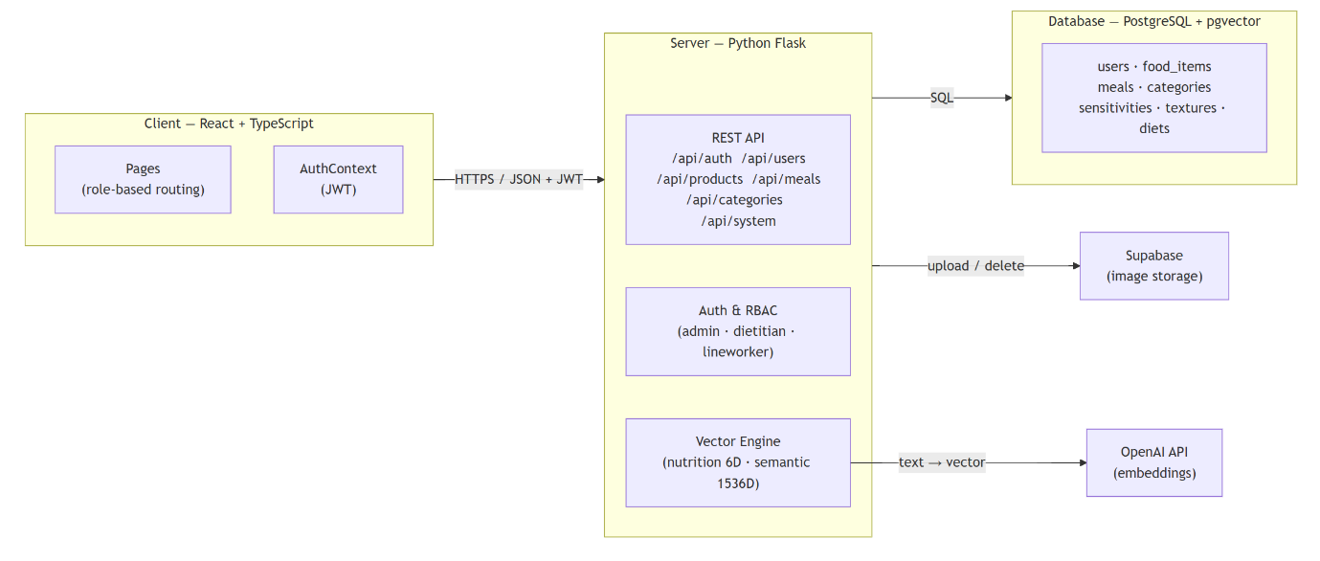

1.2 External Integrations
- OpenAI API: The system will use the text-embedding-3-small model to process text descriptions. When a new product is added, its description is sent to this API to create "vector embeddings" (mathematical representations of the text). These embeddings are then stored locally in our database. This approach ensures that future searches are fast and cost-effective, as the system does not need to call the external API repeatedly
- Supabase Storage: Product images are uploaded to and served from a Supabase cloud storage bucket. The backend handles all upload and delete operations, returning a public URL that is stored alongside the product record in the database.

2. System Logic & Data Flow

2.1 Data Life-Cycle
The system logic is driven by three distinct data phases: Ingestion, Construction, and Execution.
- 1. Ingestion Pipeline (Dual-Vector Generation): When a Dietitian saves a product, the backend processes the input in sequence. First, if an image is provided, it is uploaded to Supabase cloud storage and its public URL is stored with the product record. Next, it calculates a Nutritional Vector - a 6-dimensional array of macro-nutrients (calories, protein, carbohydrates, fat, sugars, and sodium) - for mathematical comparison. Finally, a structured semantic description built from the product's fields is sent to the OpenAI API to generate a Semantic Embedding (1536-dimensional vector). Both vectors are stored in PostgreSQL.
- 2. Meal Construction Engine: While planning a meal, the system automatically filters products against the selected allergen restrictions and food texture (IDDSI) level in real-time. Products that contain a selected allergen are hidden from the list; products that may contain them are shown with a visible warning flag. Simultaneously, the system calculates and displays the total nutritional values instantly. This ensures that every meal built by the Dietitian is both safe and nutritionally sound before it is saved.
- 3. Execution & Reporting: Once a meal is saved, the system creates a permanent snapshot of all nutritional totals and the exact safety filters applied at that moment, ensuring a traceable record. Line workers access a read-only meal catalog showing only approved, finalized meals - with no ability to modify data. Administrators can also export a full system backup as a ZIP file containing all product data as CSVs and the complete image library, which can be re-imported to restore or migrate the system.
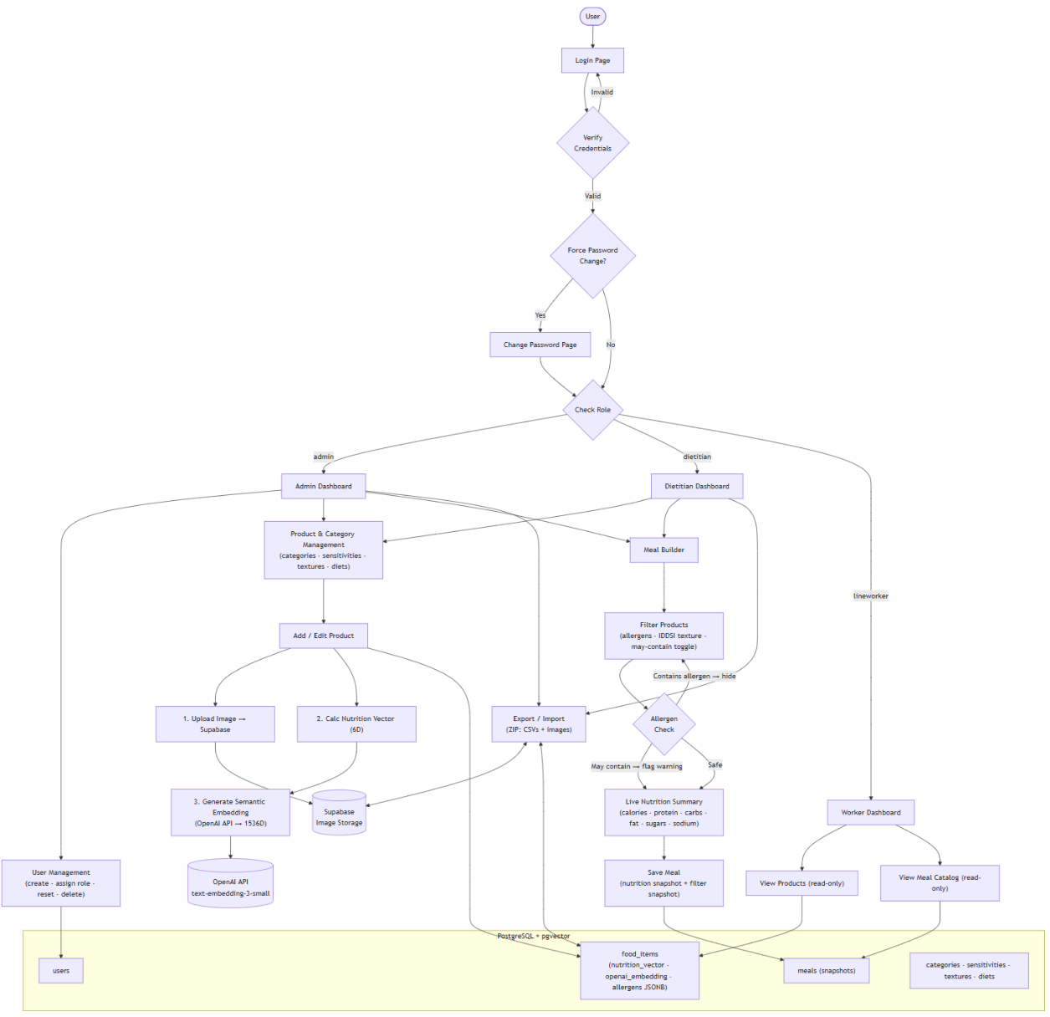

2.2 Data Interaction Flow
2.2 Data Interaction Flow The following diagram illustrates the specific movement of data between system actors, the application logic layer, and the data persistence layer.
All requests from the three user roles Admin, Dietitian, and Line Worker pass through a JWT authentication middleware, which verifies the token and enforces role-based access before routing to the appropriate engine. Line Workers are granted read-only access to the database directly, with no write operations permitted.
The Product Ingestion Engine coordinates a three-step pipeline: it uploads the product image to Supabase cloud storage and receives a public URL in return; it then sends a structured semantic description of the product to the OpenAI API and receives a 1536-dimensional embedding vector; finally, it writes the complete food item record including both vectors to PostgreSQL in a single operation.
The Meal Builder Engine reads products from the database filtered by selected allergen restrictions and IDDSI texture level, then writes a finalized meal record as an immutable snapshot of both the nutritional totals and the active filters.
The Backup Engine reads all records from the database and downloads the corresponding images from Supabase to produce a portable ZIP export. During import, the process is reversed: images are re-uploaded to Supabase, new public URLs are generated, and all records are re-inserted into the database.
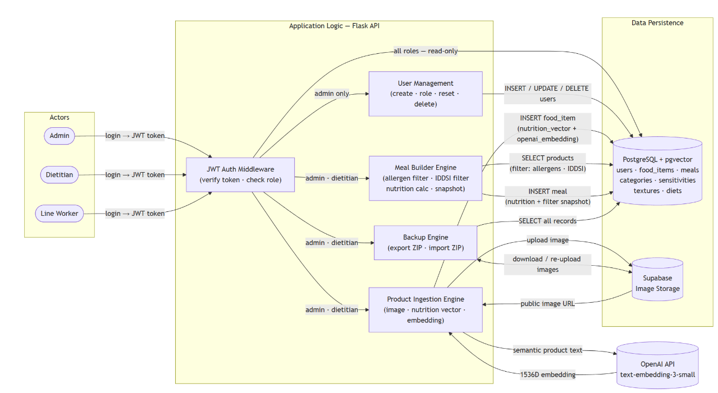

3. Database Design

3.1 Core Schema Definitions
The database utilizes a normalized relational schema integrated with vector storage.
Users Table: Manages system access by assigning one of three roles to each user. Admins have full control over all data and are the only role that can create, delete, or reset other user accounts. Dietitians have full CRUD access to products, meals, and all reference data (categories, sensitivities, textures, diets). Line Workers have read-only access to products and the meal catalog. A must_change_password flag is also stored per user, forcing a password reset on first login before access is granted.
Products Table (food_items): The central record for all food items. Each product stores basic details (name, company, IDDSI level, image URL, category, texture) alongside six macro-nutrient fields (calories, protein, carbohydrates, fat, sugars, sodium) and two computed vector columns:
- nutrition_vector: A 6-dimensional vector built directly from the six macro-nutrient values, stored for future nutritional comparison and clustering use.
- openai_embedding: A 1536-dimensional vector generated by the OpenAI API (text-embedding-3-small) from a structured text description of the product, stored for future semantic search capability.
Allergen data is stored directly on the product as two JSONB arrays: contains (confirmed allergens) and may_contain (potential cross-contamination). Additional clinical fields texture_notes, allergy_notes, forbidden_for, and properties capture free-form medical annotations.
Reference / Lookup Tables: Four small tables categories, sensitivities (allergens), textures, and diets store the controlled vocabularies used across the system. The sensitivities table defines the master list of allergen names; the actual per-product allergen assignment is stored as JSONB arrays inside food_items rather than in a join table, allowing flexible multi-value storage.
Meals Table: A single table stores the complete meal record there is no separate header/detail split. Each record holds the meal name, description, and linked diet_id, alongside an ordered product_ids JSONB array listing the included products. Two immutable snapshots are written at save time and never modified:
- Nutrition snapshot: Pre-computed totals for all six macro-nutrients (total_calories, total_protein, etc.), reflecting the meal's nutritional content at the moment it was saved.
- Filter snapshot: The exact safety constraints active during meal creation filter_restriction_ids, filter_texture_ids, and the filter_show_may_contain toggle providing a traceable record of what rules were applied.

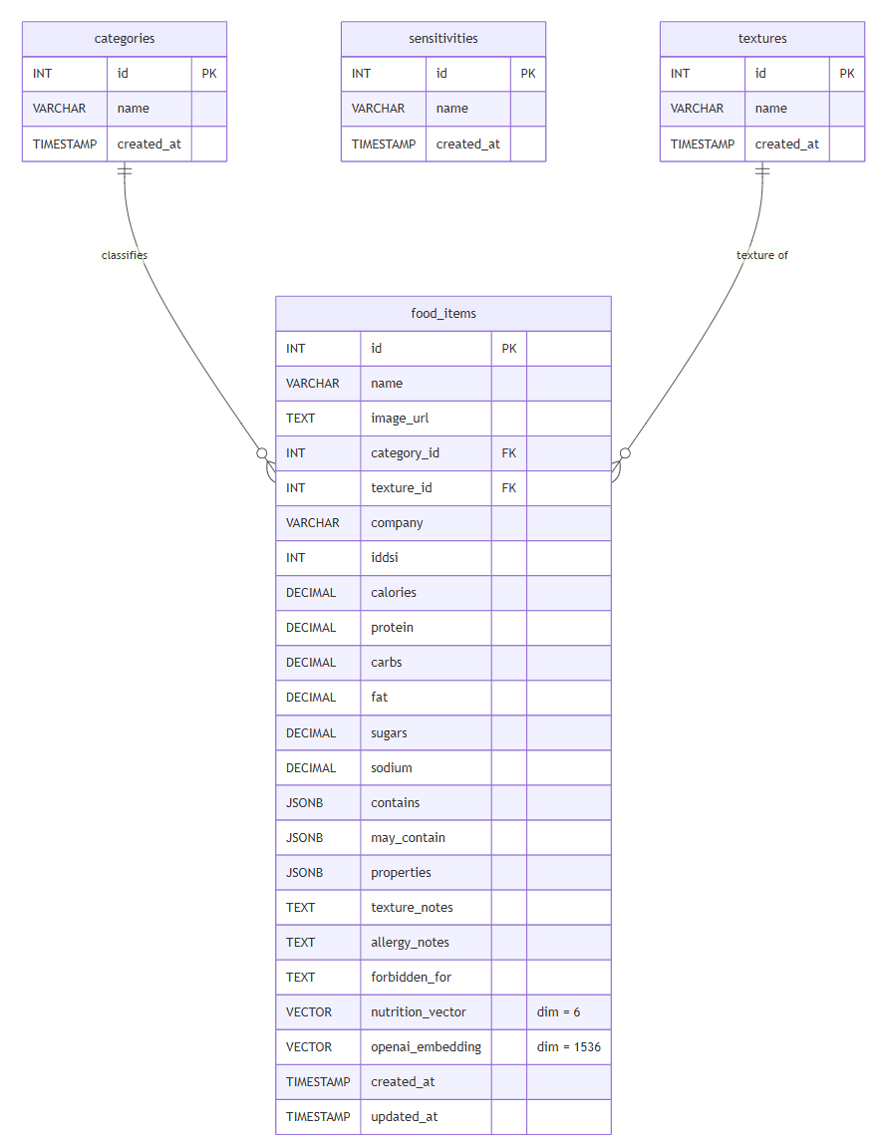
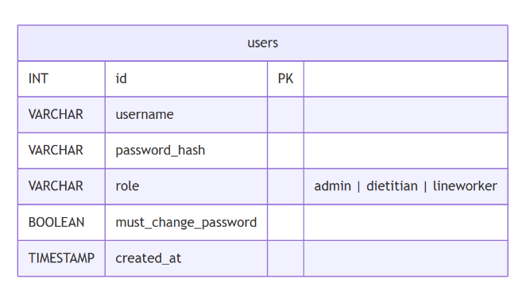
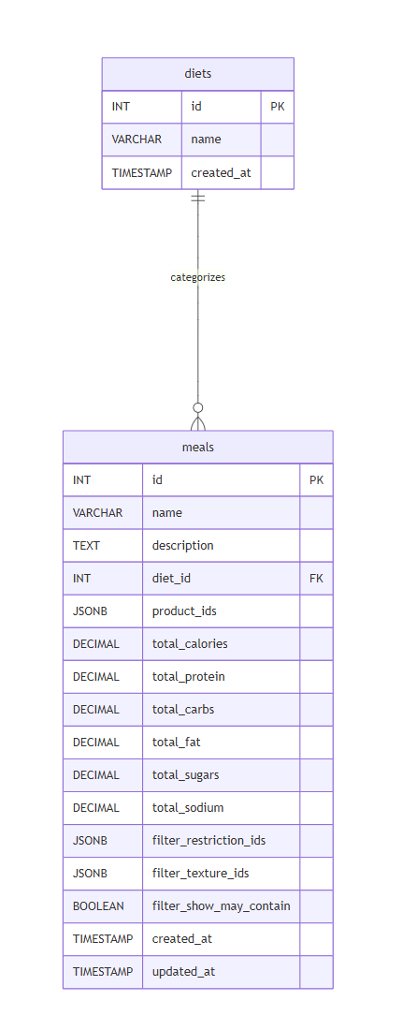

4. Algorithmic Specifications

4.1 Semantic Vector Search (Cosine Similarity)
To enable conceptual discovery (searching with natural language), the system utilizes Cosine Similarity rather than standard SQL keyword matching. User queries are converted into high-dimensional vectors and compared against stored product embeddings. The system calculates the angular distance between vectors; a value closer to 1.0 indicates a high degree of semantic similarity. This allows the search engine to understand context and intent beyond literal text matches.

4.2 Nutritional Proximity (k-Nearest Neighbors)
The “Smart Substitute” feature employs a k-Nearest Neighbors (k-NN) algorithm to identify products with equivalent nutritional profiles. When a target product is selected, the system scans the nutrition_vector space using Euclidean Distance to identify the $k$ closest data points. This ensures that suggested substitutes are mathematically close to the original item in terms of protein, fat, and caloric content.

4.3 Nutritional Clustering (K-Means)
To help the menu planning process grouping products, the system employs K-Means Clustering to categorize inventory based on nutritional density rather than arbitrary food categories. The algorithm analyzes the nutrition_vector of the entire database, iteratively grouping products into distinct clusters based on their proximity to calculated centroids in the multi-dimensional space. This automatically segments the inventory into meaningful nutritional groups such as "High-Protein/Low-Fat" or "Calorie-Dense" allowing Dietitians to discover suitable items for specific dietary protocols without manual tagging.

5. API Interface Specifications

5.1 Internal Routes (Client to Server)
Authentication
- POST /api/auth/login - Verifies credentials and returns a JWT token containing the user's id, username, role, and must_change_password flag.
- POST /api/auth/change-password - Authenticated. Updates the user's password and reissues a new JWT with must_change_password set to false.
- GET /api/auth/me - Returns the current user's info decoded from the active token.
User Management (Admin only)
- GET /api/users - Lists all registered users.
- POST /api/users - Creates a new user with a temporary password and sets must_change_password to true.
- PATCH /api/users/:id/role - Updates the role assigned to a user.
- POST /api/users/:id/reset-password - Resets a user's password to a new temporary value and forces a password change on next login.
- DELETE /api/users/:id - Permanently removes a user account.
Product Management (Admin & Dietitian)
- GET /api/products - Retrieves the full product inventory with resolved category names.
- POST /api/products - Triggers the ingestion pipeline: calculates the 6D nutrition vector, sends a structured semantic description to the OpenAI API to generate the 1536D embedding, and saves the complete record.
- PUT /api/products/:id - Updates product fields and regenerates both vectors.
- DELETE /api/products/:id - Deletes the product record and removes its image from Supabase storage.
- POST /api/upload - Uploads a product image to Supabase storage and returns the public URL.
Reference Data Management (Admin & Dietitian)
The following four resources share the same CRUD pattern. Each supports individual create, update, and delete, plus a bulk CSV upload endpoint.
Resource | Prefix
Categories | /api/categories
Sensitivities (Allergens) | /api/sensitivities
Textures | /api/texture
Diets | /api/diets
Meal Planning
- GET /api/meals - Lists all saved meals, ordered by creation date (newest first).
- GET /api/meals/:id - Retrieves a single meal with all product objects fully resolved.
- POST /api/meals - Saves a meal with its ordered product list, pre-computed nutrition totals snapshot, and active filter state snapshot.
- PUT /api/meals/:id - Updates all fields of an existing meal.
- DELETE /api/meals/:id - Permanently removes a meal.
System & Backup
- GET /api/status - Health check; confirms the server and database are reachable.
- GET /api/system/export - Generates and streams a ZIP archive containing CSV files for all entities and a folder of all product images downloaded from Supabase.
- POST /api/system/import - Accepts a ZIP archive, re-uploads images to Supabase, remaps entity IDs, and re-inserts all records.
- GET /api/run-migrations - Runs idempotent schema migrations (ALTER TABLE / CREATE TABLE IF NOT EXISTS).

6. User Interface Design

6.1 Admin Views
- User Management Page: An admin-exclusive panel for managing system access. Admins can create new accounts with a temporary password, assign or change roles (Admin, Dietitian, Line Worker), reset passwords, and delete users. New users are forced to change their password on first login before accessing any other part of the system.

6.2 Dietitian Views (Admin)
- Products Page: A browsable, card-based view of the full product catalog. Dietitians can scan product details including nutritional values, IDDSI level, allergen flags, and the product image.
- Product Settings Page: The management interface for the product database. It displays all products in an expandable table where each row can be opened to edit all fields. A form at the top allows adding new products including image upload to cloud storage, all six macro-nutrient fields, allergen assignments (contains / may contain), texture, IDDSI level, and clinical notes.
- Category Settings Page: A single page for managing all four reference datasets: categories, sensitivities (allergens), textures, and diets. Each dataset has its own CRUD table with support for bulk upload via CSV.
- Meal Builder (Create Meal Page): The main meal composition workspace, split into two panels:
- Product Library (Left): A filterable product list. Dietitians select active allergen restrictions and IDDSI texture requirements; products that contain a selected allergen are hidden from the list entirely. Products that may contain a selected allergen remain visible but are flagged with a warning. A may-contain toggle controls whether these flagged items are shown at all.
- Meal Summary (Right): Displays the ordered list of selected ingredients and a live numerical nutrition summary (calories, protein, carbohydrates, fat, sugars, sodium) that updates instantly as products are added or removed. A form captures the meal name, description, and assigned diet before saving.
- Meals Catalog Page: A list view of all saved meals displayed as summary cards. Each card shows the meal name, diet type, and high-level nutritional totals.

6.3 Line Worker Views (Read-Only)
- Products Page (Read-Only): A simplified view of the product catalog with no add, edit, or delete controls. Line workers can browse product details including IDDSI level, allergen information, and nutritional values.
- Meals Catalog Page (Read-Only): The same meal catalog view available to Dietitians, presented without any editing capability. Line workers can see all finalized meals and their nutritional summaries.

